**BALDIVIS SECONDARY COLLEGE**

** Methods Units 1 and 2**

**2021 Test 6**

Mark: _____/42  
  
Weighting: 5%

Student Name _____________________________________________

**Time allowed for this task:** 45 minutes, in-class, test conditions.

Section 1: 20 minutes + 2 minutes reading time

Section 2: 25 minutes + 3 minutes reading time

**Materials required:** **Section 1** Calculator free section (20 marks)

Standard writing equipment

SCSA Formula Sheet

**Section 2** Calculator assumed section (22 marks)

Calculator (to be supplied by the student)

SCSA formula Sheet

One page A4 (double sided) hand written notes

**Other materials allowed:** Drawing templates

**Marks available:** **42 marks**

**Task Weighting: 5%**

**Question 1. [4 marks – 1, 1, 1, 1]**

|  |  |  |  |
| --- | --- | --- | --- |
| **a)** |  | **b)** |  |
|  |  |  |  |
| **c)** |  | **d)** |  |
|  |  |  |  |

**Question 2** **[4 marks – 2,2]**

Simplify the following indices, leaving your answer as positive indices:

|  |  |  |  |
| --- | --- | --- | --- |
| **a)** |  | **b)** |  |

**Question 3 [4 marks – 2,2]**

Simplify:

1. 
2. (

**Question 4 [6 marks – 3, 3]**

Simplify each of the following for $x$.

|  |  |  |  |
| --- | --- | --- | --- |
| **a)** |  | **b)** |  |

**Question 5** **[2 marks]**

Estimate a solution to the equation $2^{x}=17$, giving your estimate to one decimal place.

**END OF SECTION ONE**



**AEMAM Unit 1 – Test 6 – 2021**

**Name: Time allowed – 25 minutes**

**Calculator Assumed Section (1 x A4 page of double sided notes and approved calculators.**

**Formula sheet provided.) – 22 marks**

**Question 6 [4 marks – 1, 2, 1]**

(a) Consider the graph drawn below.

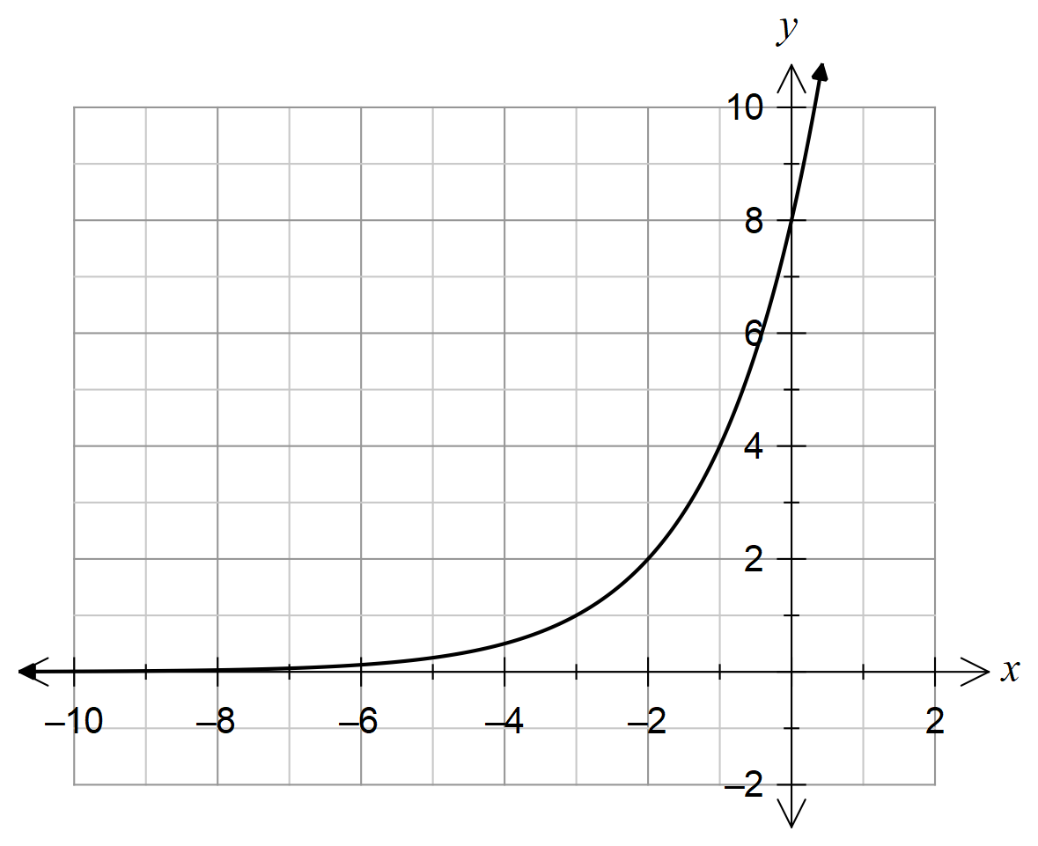

State:

(i) The equation of the horizontal asymptote.

(ii) The equation of the function drawn.

(b) If the graph of $y={0.5}^{x}$ is reflected about the *y-*axis, what is its new equation?

**Question 17 [5 marks- 2, 1, 1, 1]**

In Pascals restaurant, a chef records the internal temperature () of a roast which has been placed on the counter bench to cool down. The room temperature is $18℃$. This situation can be modelled using the formula $T\left(t\right)=45(0.5)^{\frac{t}{12}}+18$ where the temperature is measured in degrees Celsius and *t*  is the time in minutes.

(a) Determine the internal temperature, to the nearest degree, of the roast after 15 minutes.

(b) The roast is to be served when it reaches an internal temperature of $26℃$. How much time will it take for the roast to reach this temperature?

The baker of Pascals restaurant needs to heat up an apple pie which was made earlier that day.

The internal temperature of the pie is recorded. The room temperature remains at $18℃$.

The formula $T\left(t\right)=5(1.2)^{\frac{t}{12}}+18$ represents this situation where *T* is the temperature in degrees Celsius and *t*  is the time in minutes.

(c) If the roast and pie are to be served at the same temperature, how long should the pie be warmed in the over for?

(d) What instruction(s) would you give the baker so that the roast and pie are served at the same time?

**Question 8** **[8 marks: 2, 2, 2, 2,]**

|  |
| --- |
| The population of blue wrens in a particular area of the South West has been studied over 8 years.  The results are represented on the graph given below.      The population is modelled by the exponential function  and a point on the graph is indicated. |
| 1. Find the value of *b,* to 2 decimal places. |
|  |
| 1. State the annual percentage change in the population of wrens. |
|  |
| 1. Find how many wrens there were after 13 years. |
|  |
|  |
|  |
| 1. When is it predicted there will be 10 wrens left in the area? |

**Question 9 [5 marks: 2, 3]**

|  |
| --- |
|  |
| The changing population of a nation is shown below.   |  |  |  |  |  | | --- | --- | --- | --- | --- | | Year | 2010 | 2011 | 2012 | 2013 | | Population  (in millions) | 20 | 12 | 7.2 | 4.32 | |
| 1. Find the yearly percentage change in population. |
|  |
| 1. Create a rule for the population and use it to find the population in 2017. |
|  |

**END OF ASSESSMENT**